Introduction

As part of the Parish’s initial ecological action plan and in promotion of the message contained in the Holy Father’s encyclical “Laudato Si’” we have been looking for ways to increase biodiversity in our Parish. To this end we have identified an area within grounds of Saint Patrick’s Church that could be rewilded. We have also identified the graveyard beside the Parish Hall as an area in which there is an opportunity to both improve the appearance of the graveyard and promote pollinators and other wildlife. In addition, as part of our engagement with the wider community, we have been liaising with Tidy Towns in Donabate. They have shared some feedback with us from the last Tidy Towns competition regarding Saint Patrick’s Church. We have incorporated some suggestions in relation to this into this proposal also. We would be very grateful for your feedback on the proposals by 15th February 2024. It is hoped that any works would be completed by the end of February. Please submit any feedback to laudatosi2023@yahoo.com.

- Area for rewilding

It is proposed that the area identified in Exhibit 1 below be rewilded. Bees rely solely on nectar and pollen from flowers. Because wild bees don’t make honey they have no way of storing food and are always only a couple of days away from starvation. This proposal would involve planting Irish wildflowers that act as food for bees and other insects. We also propose adding selected native fruit bearing hedges such as Hawthorne in this area to serve as both food for birds and shelter for wildlife. A water butt for harvesting rainwater for use in the parish grounds will also be included here to reduce water consumption used in tending the garden.

Exhibit 1-Area to be Rewilded (perimeter marked in black)

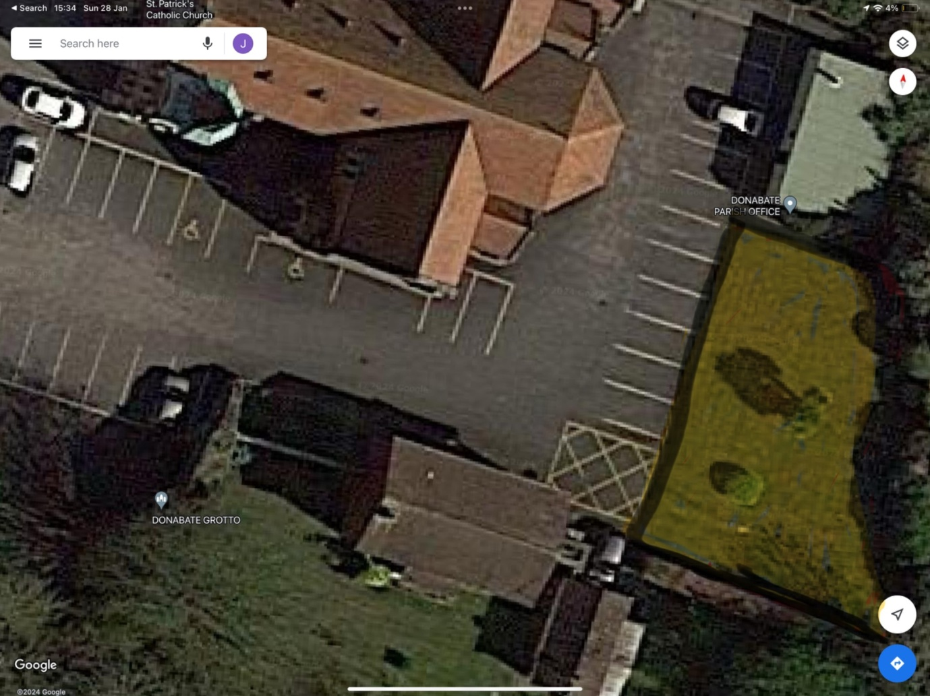

Types of Planting to be included

Exhibit 2-Irish Wildflower Meadow

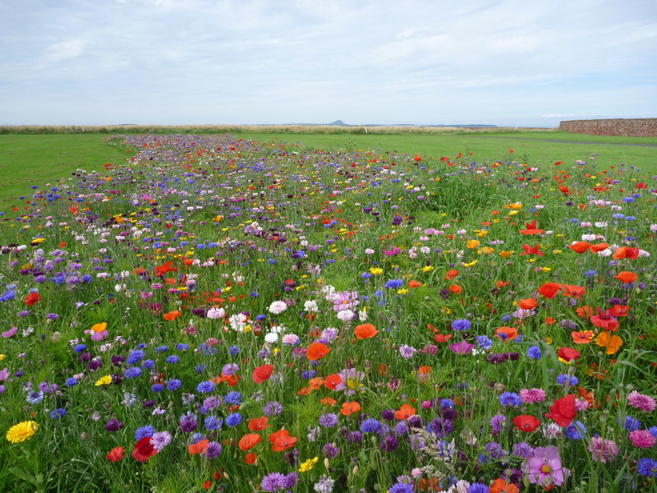

Exhibit 3-Hawthorn Hedge

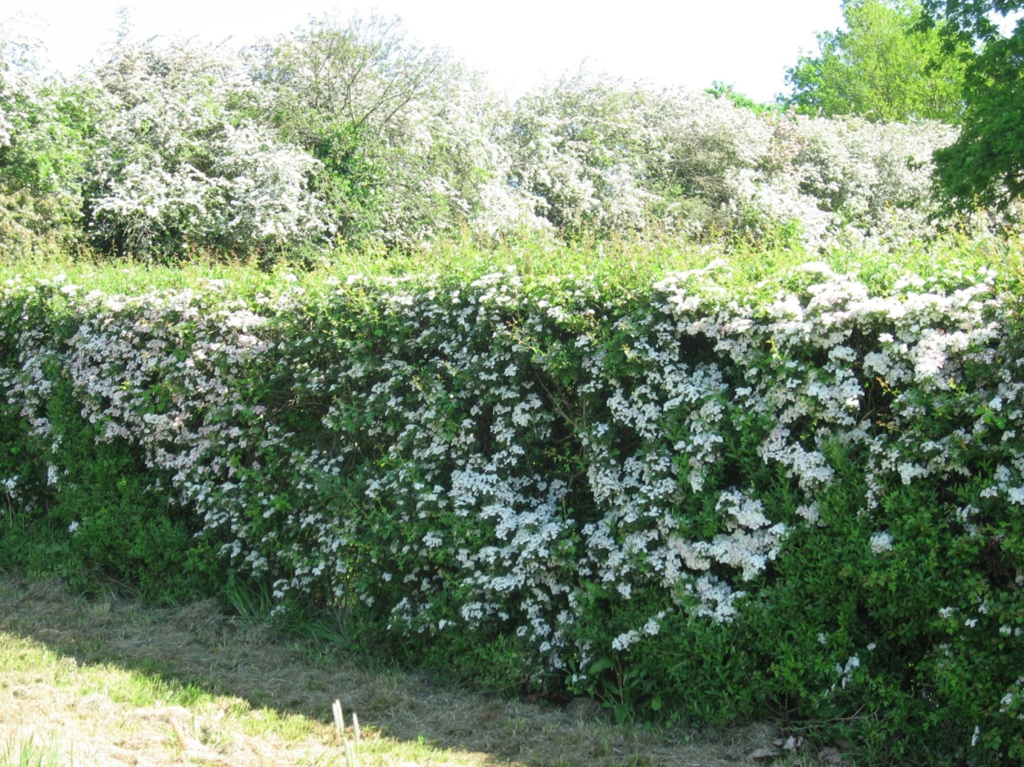

- Addition of Hedging in the graveyard

Old graveyards are a natural oasis for native plants and wildlife. It is proposed that a Hawthorn hedge (see exhibit 3 above) be added to the perimeter of the graveyard. The hedge would serve to increase privacy for those visiting the cemetery, soften its appearance generally and provide food and shelter for wildlife thereby increasing biodiversity in the parish. Immature hedging would be added to the perimeter of the graveyard in areas highlighted in black below.

Exhibit 4 -location of hedging

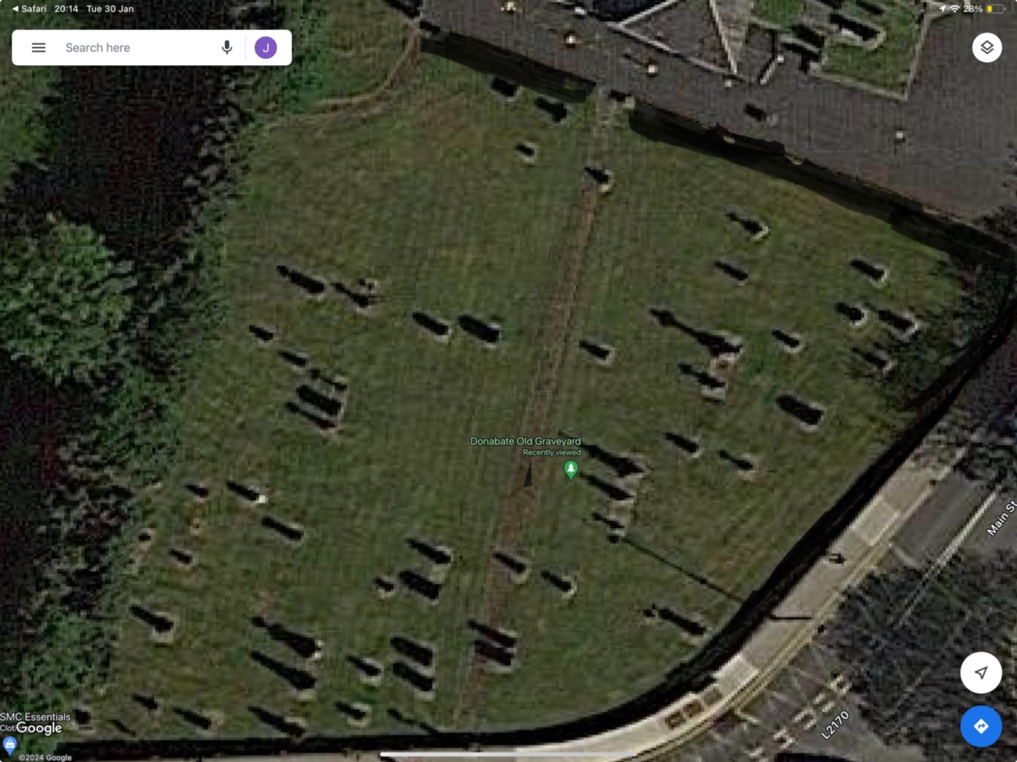

- Other Tidy Towns Recommendations

There was an observation that disclaimer/warning signs displayed on the facade of Saint Patrick’s church detracted from its appearance. It may be possible to relocate these signs to the gates of the church and away from its facade. Consideration, however, has to be given to the fact that these disclaimers must be displayed prominently.

It was also noted that the church railings might provide a better contrast with the redbrick of the building if they were painted black.

